**Parking Lot Problem**

1. **Process Overview:** A multi-storey parking lot that can hold up to ‘n’ cars at any given point in time. Each slot is given a number starting at 1 increasing with increasing distance from the entry point in steps of one.   
   When a car enters parking lot, the ticket should be issued to the driver. The ticket issuing process includes us documenting the registration number (number plate) and the colour of the car and allocating an available parking slot to the car before actually handing over a ticket to the driver .

The customer should be allocated a parking slot which is nearest to the entry. At the exit the customer returns the ticket which then marks the slot they were using as being available.  
● Registration numbers of all cars of a particular colour.  
● Slot number in which a car with a given registration number is parked.  
● Slot numbers of all slots where a car of a particular colour is parked.

1. Class Diagram:

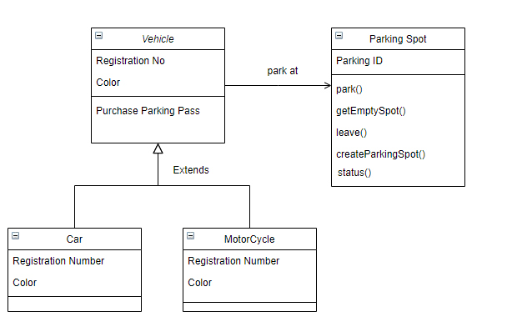

1. WorkFlow Diagram:

